TRADER(ORACLE)

1. If you want to view report, then you need to click on the **CLICK HERE** button (View Trader Report) on the middle left of our Dashboard. After clicking it, it will redirect you to Oracle Dashboard from where you can login with your username and password.

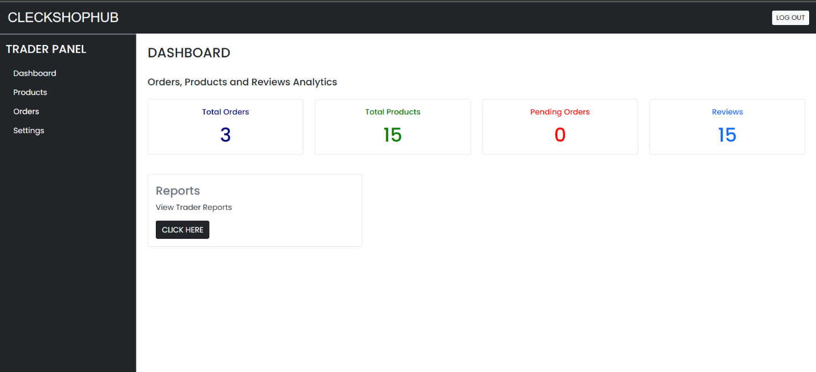

1. Clicking on this button will get you to the login page of Oracle Apex. You need to sign in with your login credentials.

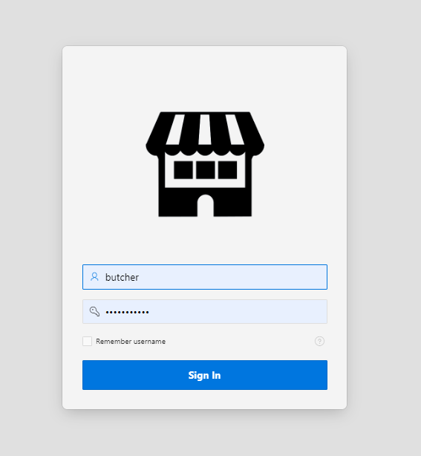

1. After logging in with correct credentials, it’ll take you to your Oracle Apex dashboard. This interface is only visible to the trader. Here, trader can view different Dashboard, Reports, Product Reviews and Pending Orders.

1. You have access to your Weekly Sale Report of sold products.

1. You have access to your Monthly Sale Report of sold products.

1. You have access to your product reviews on the master detail page.

1. You have access to view your shop and products on the master detail page.

1. To logout, Click the button with your name Butcher at the top right, click on sign out option.

